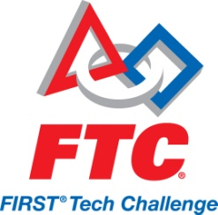

We Need You!

F.I.R.S.T. (For Inspiration & Recognition of Science & Technology) is an organization that is dedicated to “creating a world where science and technology are celebrated” through motivational robotics programs for school aged children. It is a volunteer driven program that relies on the generous donations of time, talent and resources from individuals and businesses around the world.

The Bedford Robotics program is dependent upon donations & support from individuals and businesses. FIRST Tech Challenge (FTC) robotics teams for 7th – 8th grade students allow students to explore and experience science, math and technology careers. In doing this, we help to open doors for these young students and to get them excited about and hopefully pursue math, science and technology careers. This program allows these children to work on research, project development, model building, programming and teamwork. The life skills that FIRST students learn prepare them for the job market no matter what career path they choose.

Our official challenge will not be released until September; however, we would like to get our teams registered now. This will ensure timely delivery of our kit of parts.

Our team is looking for 2012 sponsors for these FTC teams at the junior high school. If you sponsor one of them, you will be recognized in all of our media releases. If your company donates $200, we will put your company name on the team t-shirts. If your company donates $400, we will put your company name and logo on the t-shirts and if you sponsor the team with $1000 or more, we will put a large logo on our t-shirt and include your logo on our competition tri-board.

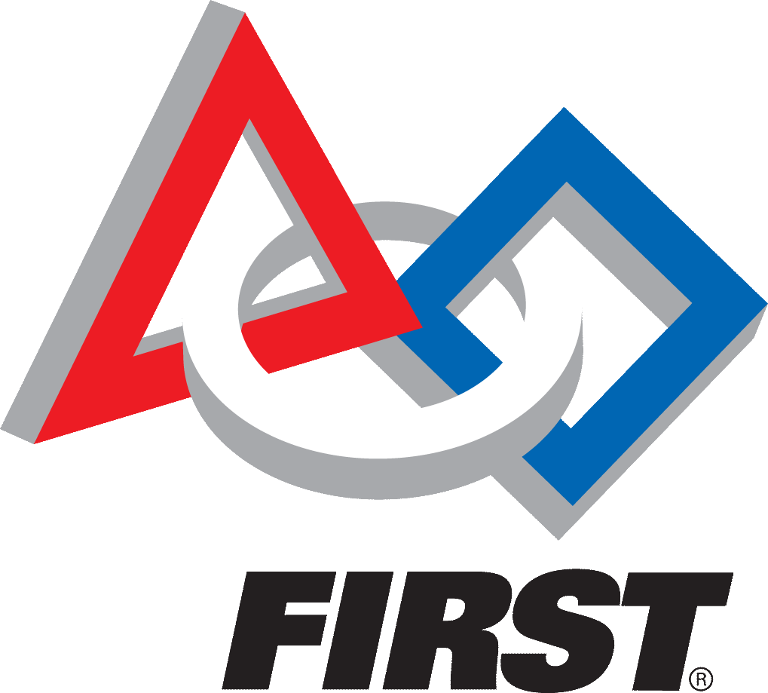More importantly than these small tokens of appreciation, your sponsorship will allow our robotics program to continue, despite the current cutbacks facing public school systems. Your donations will have lasting impacts on future generations. I hope you will consider giving to this worthy program.

Sincerely,

Debbie May Bedford Public Schools Robotics Coordinator [www.bedfordrobotics.com](http://www.bedfordrobotics.com)

------------------------Please tear off, keep the top for your records and return the bottom to us!------------------------------------

We commit to donating $_______________ to a FTC Team for the 2012-2013 season. We would like our donation to support the following team: Bedford Junior High School FTC Robotics Team

Company Name: _____________________________________________________ Phone: _____________________ Address: ________________________________________________________________ _________________ City/State/Zip _________________________________ Contact: ____________________________________________ Email: ____________________________________________________

*Please make checks payable to **Bedford Public Schools**. We will issue you a tax id donation letter upon receipt of your donation. If you need our tax-id number prior to securing a check, just let us know.

Coach, Debbie May, Bedford Public Schools 8405 Jackman Road Temperance, MI 48182 [Bxcoach1023@gmail.com](mailto:Bxcoach1023@gmail.com) 734-850-6299(fax) 734-850-6200

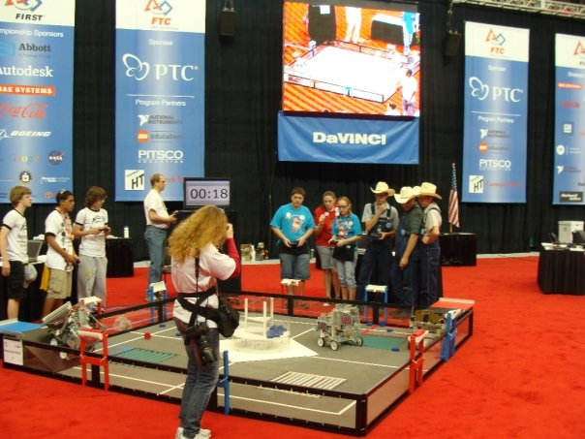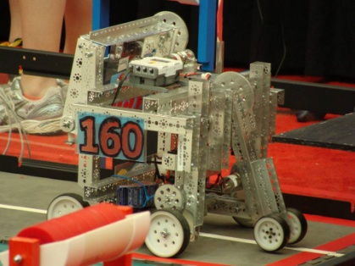

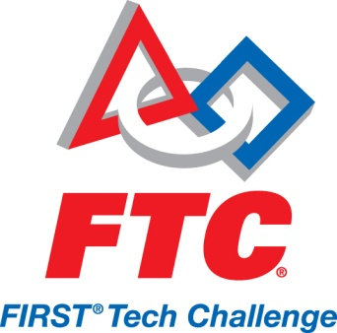

**FLL EXPENSES per team:**

Registration …………………………………………………………….……... $275.00

Base Kit of Parts ………………………………………..………..……..……$680.00

Resource Kit of Parts…………….……………………………….………..$199.00

Tournament Registration……….………………………………...$100 - $300

Spirit Buttons, Team shirts, & Trading Items……..………………….$200

Spare Parts……………………………………………………………….$300 - $500

**Total Cost per team: …………………………………..………approx. $2,000**

**Inspiring a young child ………………………………………..…… PRICELESS**